SOFE-3450 Lab 3 - Fall Monitor

February 4th 2019

Matthew Bernard 100625495, Randell Roopsingh 100470075, Matthew Cardy 100489683

**Project Estimation**

CoCoMo intermediate model

**(i) Product attributes:**

Required software reliability extent -Very high(1.4)

Size of the application database -high(1.16)

The complexity of the product -low(0.85)

**(ii) Hardware attributes:**

Run-time performance constraints -high(1.11)

Memory constraints -nominal(1.00)

The volatility of the virtual machine environment -low(0.87)

Required turnabout time -low(0.94)

**(iii) Personnel attributes:**

Analyst capability -nominal(1.00)

Software engineering capability -nominal(1.00)

Applications experience -low(1.17)

Virtual machine experience -low(1.10)

Programming language experience -high(0.95)

**(iv) Project attributes:**

Use of software tools -high(0.91)

Application of software engineering methods -high(0.91)

Required development schedule -nominal(1.00)

**Estimated Adjustment Factor = 1.2687**

**Semi-Detached**

**E=(3(100K)^1.12)*EAF**

**E=661.42pm**

**Activity Planning**

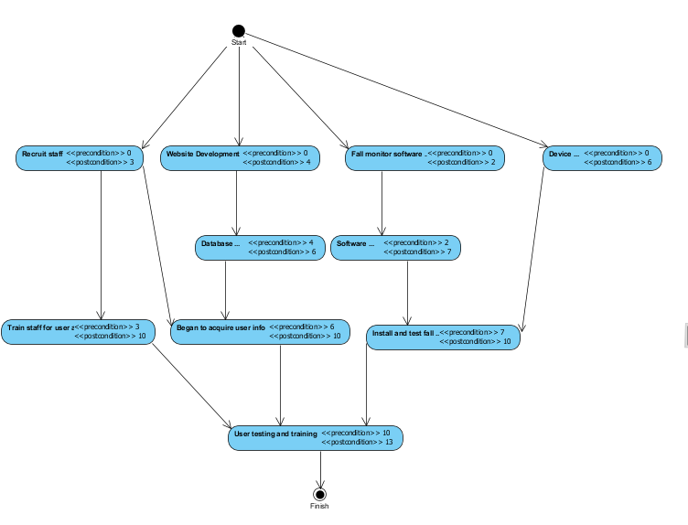

**Risks Associated**

* Issues in reliability found while initial testing
  + Countermeasure by using larger test sample.
* Issues in acquiring information from users
  + Countermeasure by insuring that the government is related throughout the process of acquiring the user health insurance information
* Issues in security of the website and database containing user information
* Issue with the device reliability
  + Non-liable for the device reliability
* Issues with staff not having sufficient experience with user service
* Issue with software development taking longer then expected
* Issue with the quality/durability of hardware
* Underestimate\overestimate budget(schedule)
* Issue of device update is not easily done